**Design Guide**

*Sanika Jain*

**Visual Site Map**

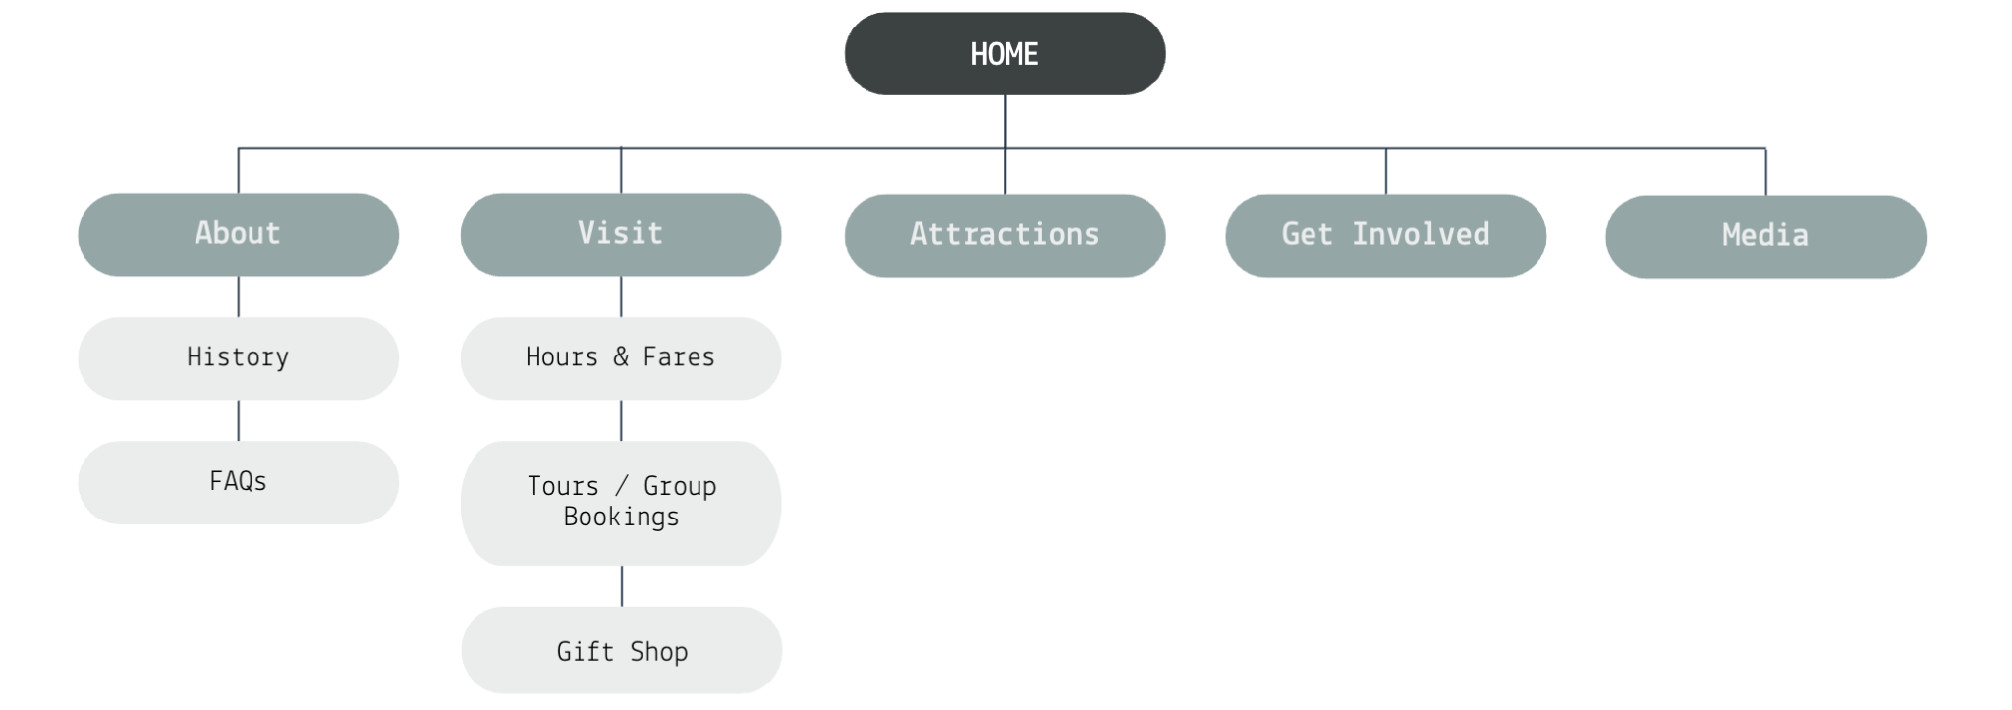

**Information Architecture & Navigation**

The website’s information architecture was designed to ensure intuitive navigation and clear content organization. The primary navigation menu groups content into five logical primary categories, About, Visit, Attractions, Get Involved, and Media, reducing cognitive load for users. The homepage provides key highlights, allowing visitors to quickly find general information as well as directions, weather, contact information, parking address, hours, and social media links. Each page maintains a consistent layout with a sticky navigation bar to ensure users can easily switch between sections. Additionally, clearly-labeled buttons and footer links enhance discoverability, making it effortless to explore various topics without confusion.

**First-Time vs. Returning Visitors**

For first-time visitors, the design prioritizes clarity and engagement. The homepage includes a brief introduction to the Duquesne Incline, along with high-quality images and call-to-action buttons guiding them to essential pages like "Plan Your Visit" or "Explore the Area." The site also highlights popular attractions and FAQs to provide a well-rounded overview. For returning visitors, the focus is on quick access to frequently used features. A persistent navigation menu, clearly labeled sections, and a detailed footer allow them to locate details on fares, parking, and group bookings without unnecessary clicks. This balance ensures a seamless experience for all users.

**Design Evolution**

The transition from wireframing to development involved multiple refinements to improve usability and aesthetics. Initial wireframes emphasized content hierarchy and user flow, ensuring that key information, such as directions and fares, was immediately accessible. Based on feedback, we adjusted spacing, font sizes, and contrast to enhance readability and accessibility. The final design incorporates a modern yet classic color palette, reflecting Pittsburgh’s rich history while maintaining a contemporary feel. Additionally, interactive elements like an image gallery and Google Maps integration were included to make the site more engaging. The end result is a visually cohesive and user-friendly platform that meets the needs of both tourists and locals.